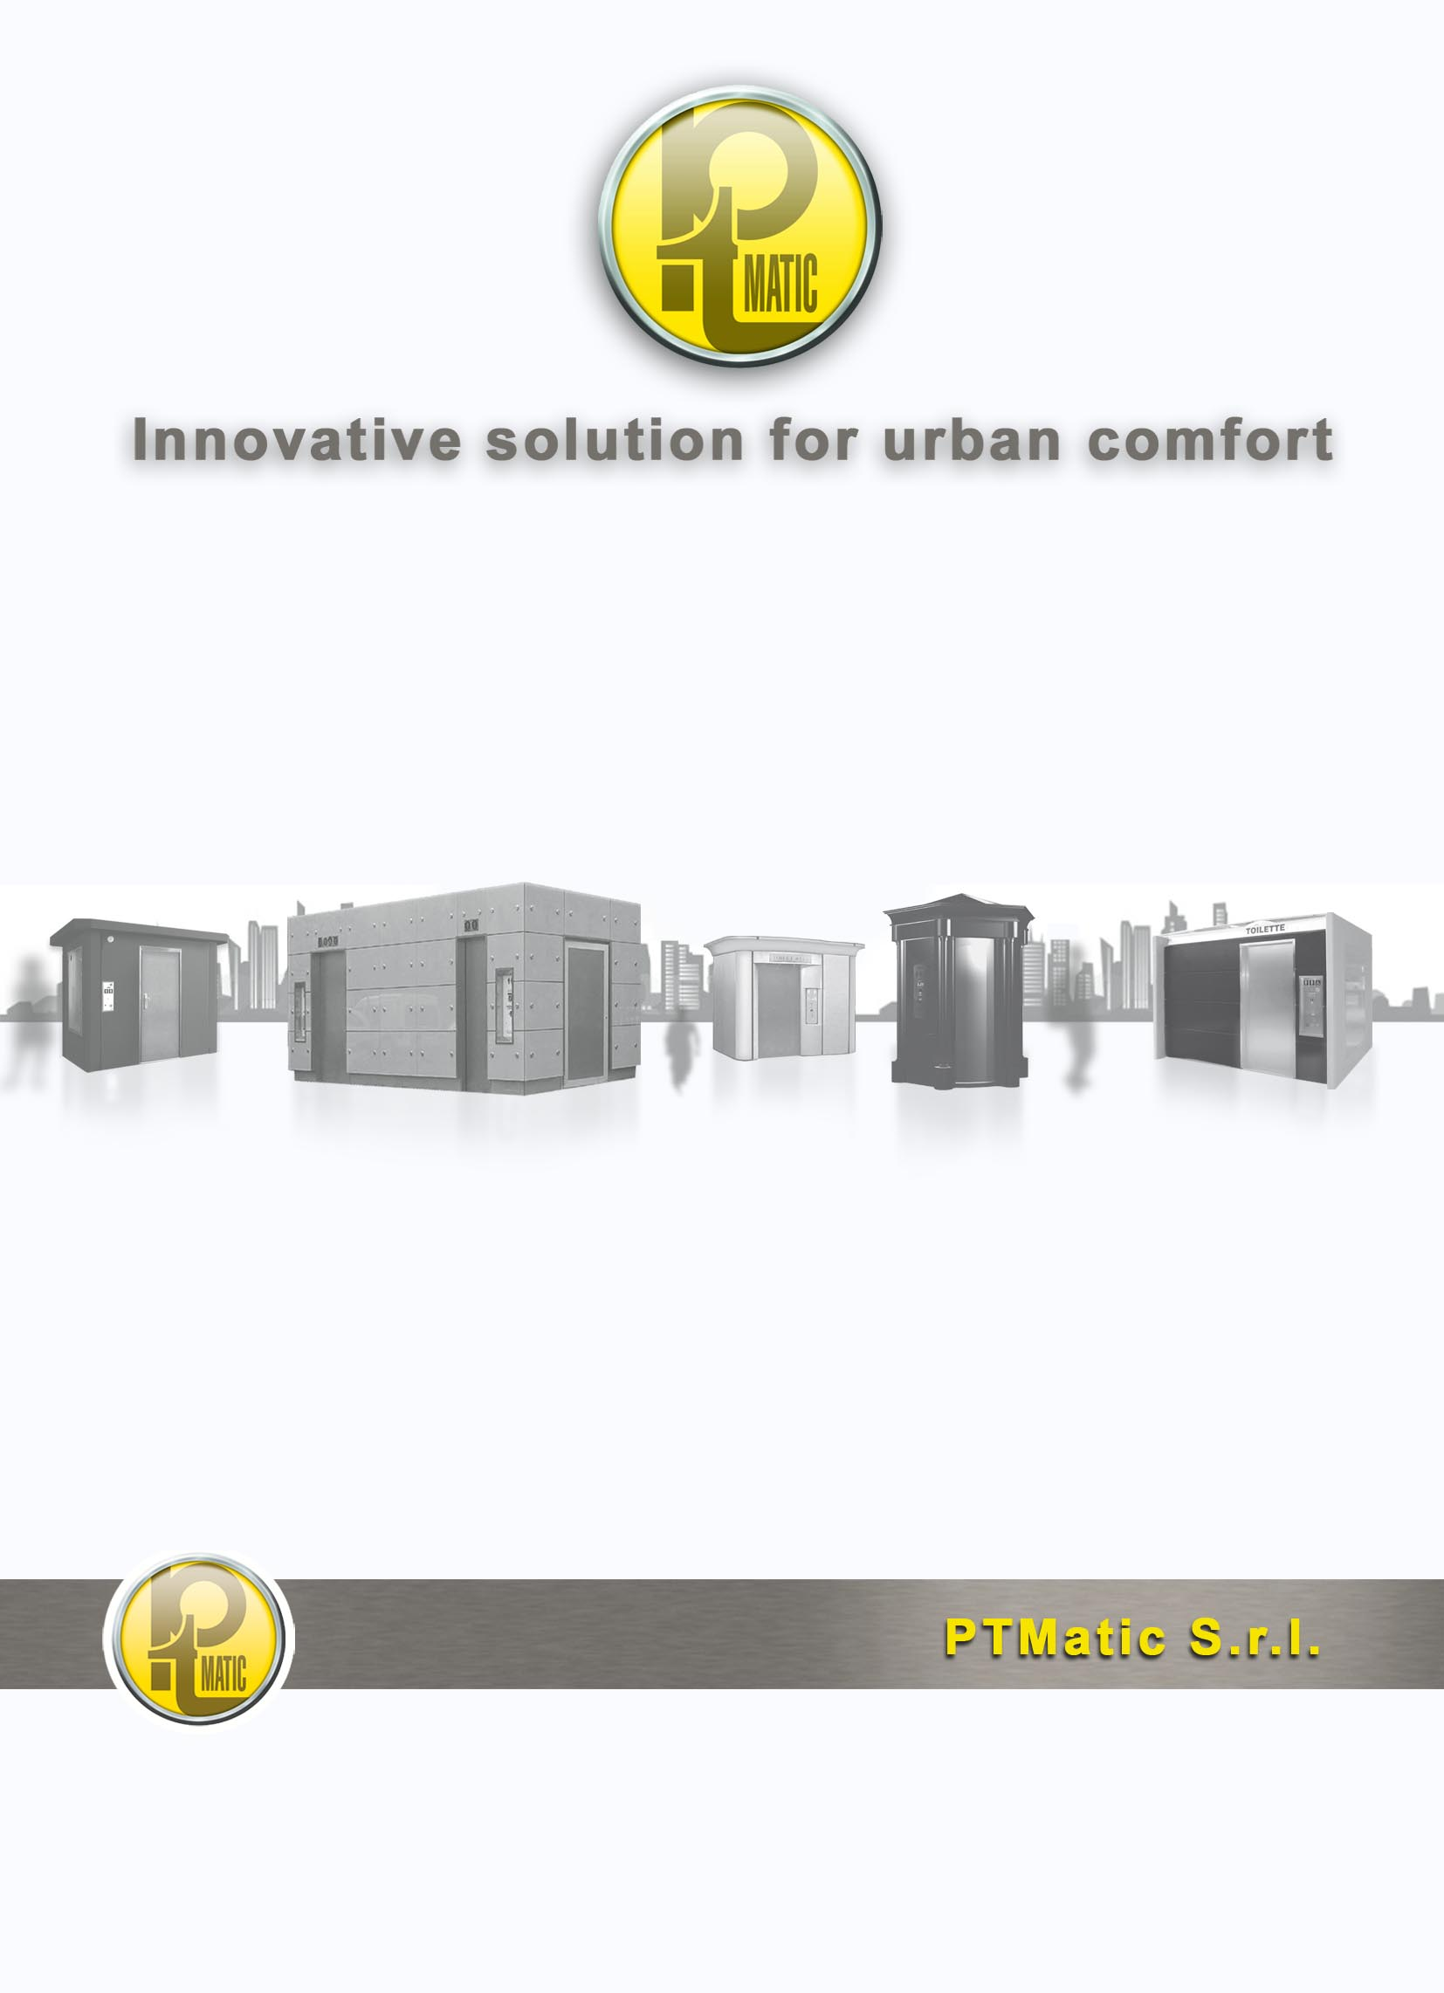

TMATIC
TECHNICAL FEATURES

TMATIC
Automatic self clearing toilet
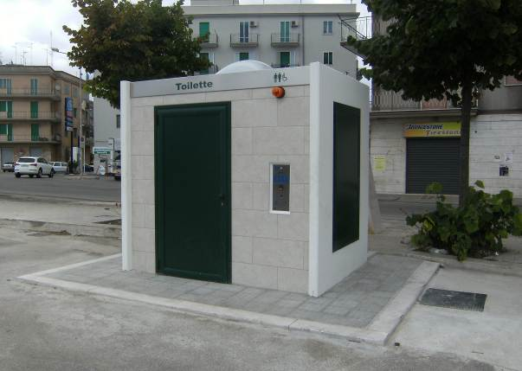

CHARACTERISTIC
The self-cleaning toilet model TMATIC has a rectangular plan. External sizes are 1.98 m. x 2.80m. and a height of 2,43 m.. Pod can easily finished or clad to have different design.
The toilet use by disabled people on wheelchair is allowed by the user room sizes (m 1.80-2.05 x 1.65 cm), by the arrangement of sanitary equipment and accessories which are in conformity with the mostly European laws.
The main feature of toilets is the automatic washing with disinfection of:

- Inside of the WC bowl through water thin layer during use;
- Inside and outside of the bowl (expulsion) at the end of its use with sitting surface drying;
- Inside the hand basin during use;
- Wall, up to a height of 0.8 m near the bowl;
- Floor, providing removal of waste, with sprinkler.
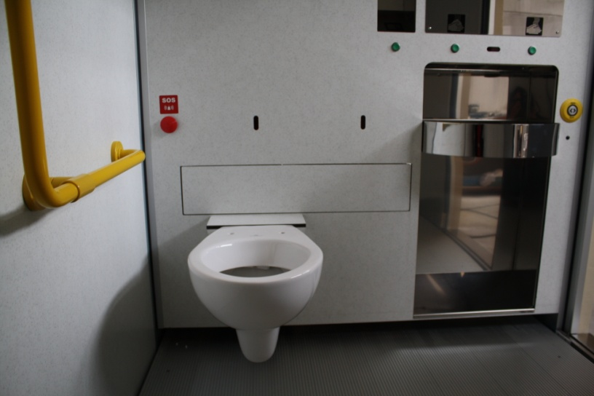

The unit is provided in the standard version as described and can be fitted with a series of accessories upon request.

STRUCTURE
- Single block box-like structure, fitted with vibrated reinforced concrete panels having a 7 cm deep and concrete cover flat slab having a minimum width of 7 cm and a reservoir to channel rain water. The slab is waterproof through a bitumen and glass fibre sheath. Rain water flow with collection in a single point. Conductor pipe is connected to the unit discharge system. It’s located inside the technical area.
- Precast concrete basement, all set up for connection to urban water, electric and sewage systems so as to minimize time and site operational works.
- Beige coloured on front and back side and grey on side (For different solution refer to the Optional Standard Equipment Sheet).
- A square based opal polycarbonate air-lighting dome, located on the cover and assembled on appropriate spacers ensures a natural ventilation, beside the forced one. Its shape and size allow an appropriate natural lighting combination and attenuates the user’s closeness sensation.
- AUTOMATIC closure door, fitted with aluminium sheet frames, with vandal resistant oil pressure unit for the automatic closure. Technical area access room fitted with two leaves. Locks are usually grey coloured.
- All internal walls of user room are coated HPL panels clear color. The ceiling is processed with low resin content synthetic paints to ensure its transpiring.
- The floor is manufactured with aluminium profile striped slip-proof foot board with washing liquid collecting reservoir
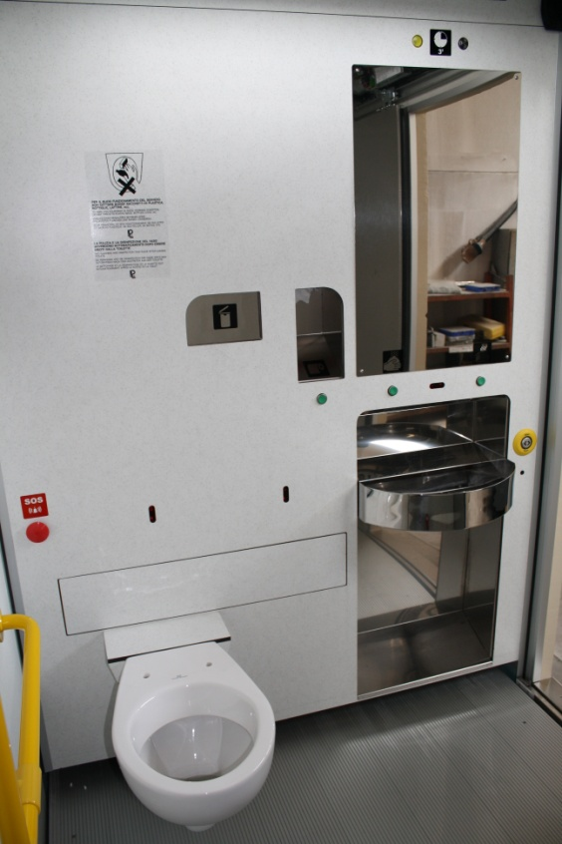 User room

FEATURES
- Detection of user presence inside the sanitary service performed with antivandal radar device.
- Hanging baked clay bowl.
- Baked clay washbasin of appropriate position and shape which ensure the simplicity by the users.
- Automatic water button-controlled dispensers, providing soap and hot air to dry hands. Soap supply is pre-set to avoid waste.
- Automatic internal lighting, in addition to natural lighting.
- Stainless steel shatterproof mirror, pegs, made of galvanized steel zinc coated with extruded nylon handles for disabled people.
- Manual toilet paper distributor recessed into the wall, fitted with stainless steel slide.
- Recessed stainless steel waste basket fitted with fireproof smoke proof closing door.
- External vandal resistant warning panel. The basic version is fitted with button for free usage. LCD display on the sheet with instructions in four languages, warning indicating the causes of out of service.
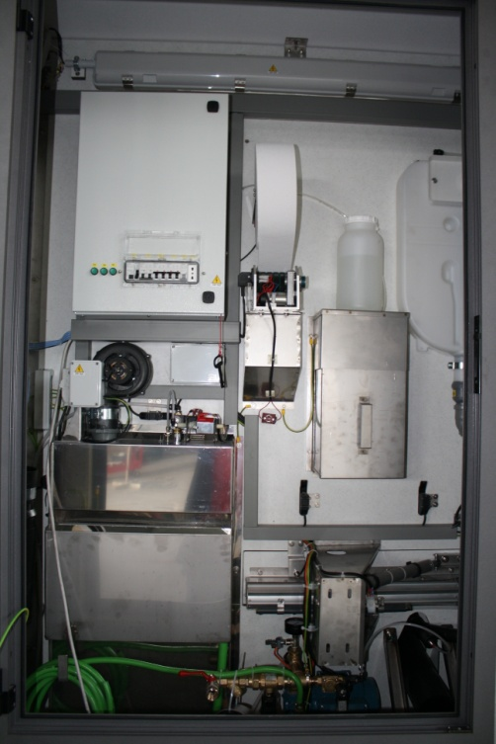 Vano Tecnico TMatic

- Emergency button located near the bowl which operates the door unlocking and activates the emergency optical and acoustical warnings.
- Disinfectant liquid tank fitted with “minimum level” control and dosing pump.
- Washing device, sanitation and wc bowl sitting surface automatic drying.
- Total and partial usage cycle counter.
- Forced ventilation system to change air inside the user room.
- Use timer of the unit, fitted with automatic door unlocking at the pre-set time end, through optical/acoustical warning of the remaining three minutes.
- Electrical protection and control panel, fitted with differential switch (idn 0.03°) and microprocessor electronic system to manage all operations of user presence and toilet washing. The system allows to change simply: operating time, unit usage price, time at disposal for the user; disinfectant quantity, toilet paper, floor washing duration.

OPTIONALS

Exterior fine

ACA30 | External fine gravel finishing in the required colour.
ACA31 | External tiles cladding on front and rear walls, gres ceramic, 30 x 60 cm., color on request.
ACA32 | Perimeter moulding, type "historic" cornice, gray mica
ACA12 | Moulding metal perimeter front and rear, complete with front canopy in tempered glass. LED light on front.

Optionals

ACA60 | Sliding door with stainless steel finish automatic opening and closing electrically operated. In lieu of hinged door.
ACA01 | Winter environment heating for temperatures up to – 5°C
ACA02 | Winter environment heating for temperatures up to -15°C
ACA04 | Automatic depletion device of the water system for temperatures lower than the expected minimum ones.
ACA05 | Multicoin-operated equipment fitted with coin return device for door opening control, coin-collecting box ad usage cycle counter.
ACA06 | Recognition magnetic card reader..
ACA07 | PTMatic Unit remote control through transmission of “Out of Service” warning by means of the telephone line.
ACA09 | Sound emission with the possibility of diffusing pre-recorded messages.
ACA13 | Stainless steel hanging bowl.
ACA22 | Toilet paper automatic dispenser

Use Cycle
With the introduction of the currency in the coin box (use to payment) is qualified automatically:
The lighting system of toilette
The opening of the door
The available time count down
The "occupied" signal on the coin box
The increment of an unit of the counter;
The sonorous spread vocal signal (on request);
The distribution of the veil in the bowl;
The fan for air re-cycle.
The automatic dispensers of water, soap, air, and of the hygienic paper.
From the moment in which the cabin it comes occupied, the control device, verified the weight on the footrest, it enters in occupied state and come qualified following operazion:
The toilet is illuminated;
The door closes automatically;
Control and security systems are activated;
Available time count down starts.
Once the use is done, the user gets out of the toilet. In the that case the customer or other person re-enters before closing of the door, the same one is reopened and enters in function the signaler (optical andl acoustic) of emergency.

When toilet is free, begin process:
Closing of the door;
Extinction of the lighting system lamp;
Extinction of the lighting system lamp
Switch off of the security systems;
Switch off of automatic dispenser;
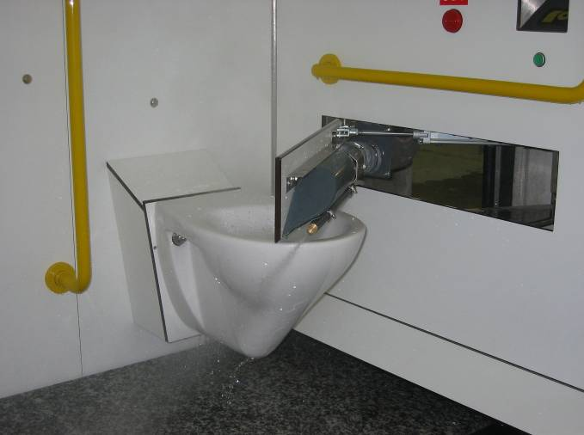
The washing system of the bowl
Consent for the beginning of the washing cycle and disinfection of the toilette;
Reset of use time.
To the term of the washing cycle, before making available the unit for a successive one I use, it comes verified the efficiency of all the equipment..

TECHNICAL SHEET T CAB H

Electric
Electrical connection without heating or Air | 220V F.N.3KW
Electrical connection with Air condition or heating system | 220V F.N.6KW
Minimal section feeding cables | 6 mm²
Current max scattered | 0.03A
Electrical and signal voltage | 5, 12, 24V

Water plan
Tube fresh water | ∅ ¾”
Minimal net pressure | 1,5 atm.
Tube drainage dirty water | ∅ 110 mm.
Tube drainage floor | ∅ 90 mm.

T CAB DRAWINGS
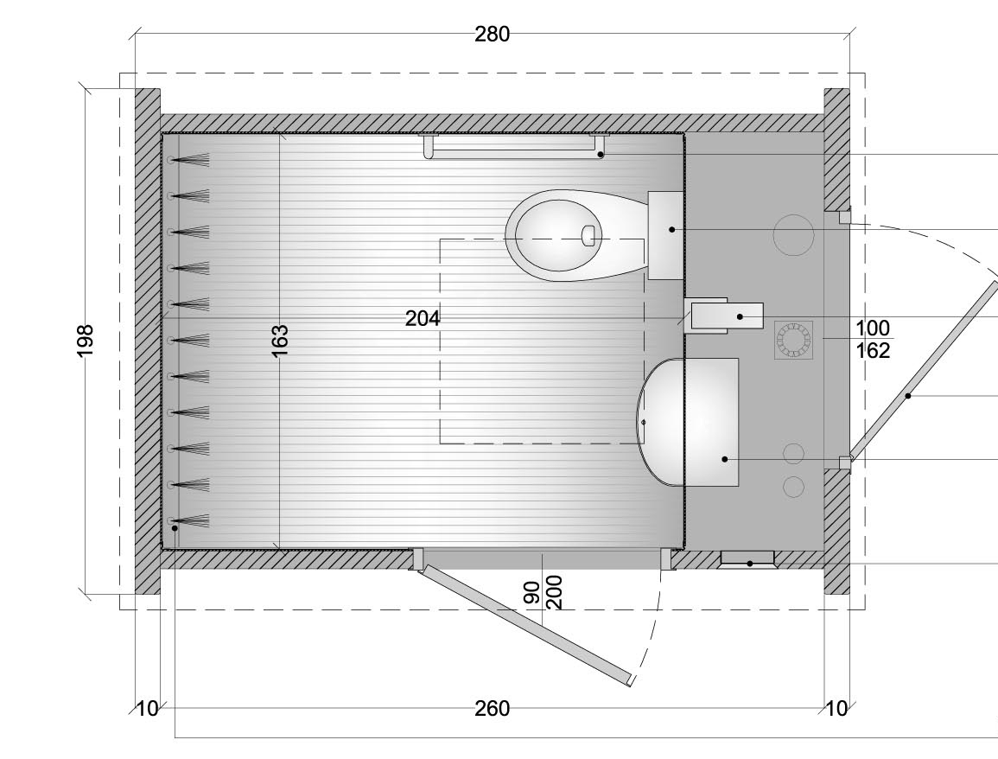pianta TMatic
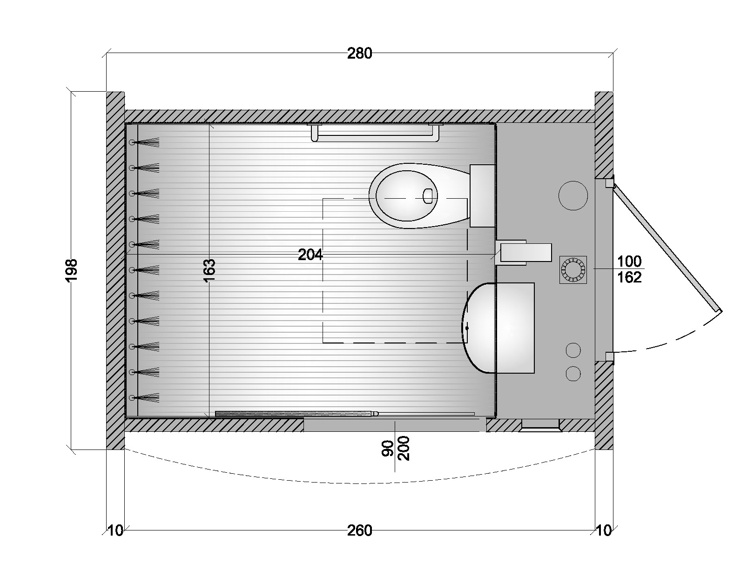pianta TMaticS

PORTFOLIO T CAB
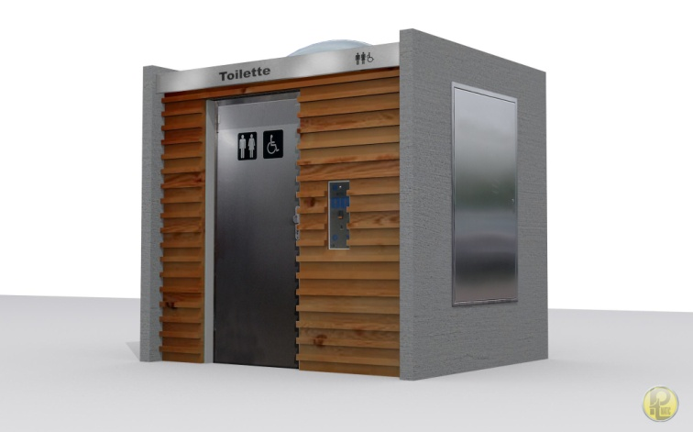 TMATIC- wood

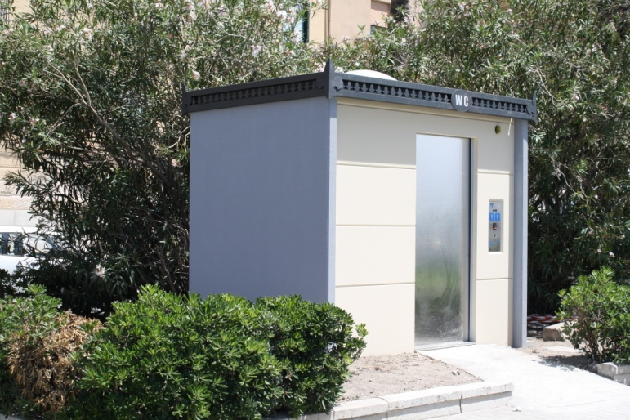T CAB Historic - TRAPANI

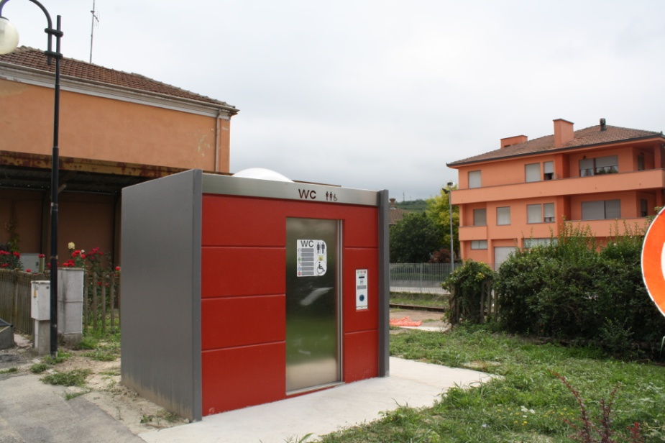 T CAB MIDDLERKERKE

